
(All rights reserved)
DEPARTMENT OF STATISTICS & ACTUARIAL SCIENCES
SCHOOL OF PHYSICAL & MATHEMATICAL SCIENCES
FIRST SEMESTER, 2025/2026 ACADEMIC YEAR
M.SC. STATISTICS

Submitted by JOSEPH KOSSI DESSOUASSI
STUDENT ID: (22425119)

ASTA 607: COMPUTATIONAL STATISTICS – EXAM

QUESTION 1 – DATA STRUCTURE AND GROUP COMPOSITION

- Description of the “crabs” dataset.
The crabs dataset is a built-in dataset from the MASS package in R. It contains 200 observations and 8 variables, describing 5 morphological measurements taken on 50 crabs from each of two colour forms (Blue and Orange) and both sexes (Male and Female), belonging to the species Leptograpsus variegatus, collected at Fremantle, Western Australia.
The eight variables are as follows:
- sp - Species/colour form: "B" for Blue or "O" for Orange
- sex - Sex of the crab: Male or Female
- index - An index from 1 to 50, identifying each crab within each of the four groups (Blue Male, Blue Female, Orange Male, Orange Female)
- FL - Frontal lobe size, measured in millimetres (mm)
- RW - Rear width, measured in millimetres (mm)
- CL - Carapace length, measured in millimetres (mm)
- CW - Carapace width, measured in millimetres (mm)
- BD - Body depth, measured in millimetres (mm)
The dataset is perfectly balanced, with exactly 50 observations per group combination, making it well-suited for group comparisons across species and sex without concerns about unequal sample sizes. The five continuous morphological measurements (FL, RW, CL, CW, BD) are all numeric, while sp and sex are categorical variables.

- Load the dataset and display its structure.
> str(crabs)
'data.frame': 200 obs. of 8 variables:
$ sp : Factor w/ 2 levels "B","O": 1 1 1 1 1 1 1 1 1 1 ...
$ sex : Factor w/ 2 levels "F","M": 2 2 2 2 2 2 2 2 2 2 ...
$ index: int 1 2 3 4 5 6 7 8 9 10 ...
$ FL : num 8.1 8.8 9.2 9.6 9.8 10.8 11.1 11.6 11.8 11.8 ...
$ RW : num 6.7 7.7 7.8 7.9 8 9 9.9 9.1 9.6 10.5 ...
$ CL : num 16.1 18.1 19 20.1 20.3 23 23.8 24.5 24.2 25.2 ...
$ CW : num 19 20.8 22.4 23.1 23 26.5 27.1 28.4 27.8 29.3 ...
$ BD : num 7 7.4 7.7 8.2 8.2 9.8 9.8 10.4 9.7 10.3 ...

Interpretation:
The output confirms that crabs is a data frame with 200 observations and 8 variables. The variables can be classified into two types:
- Categorical (Factor): sp has 2 levels - "B" (Blue) and "O" (Orange); sex has 2 levels - "F" (Female) and "M" (Male). These are stored as factor variables in R.
- Integer: index is a whole-number identifier ranging from 1 to 50 within each group.
- Numeric (Continuous): FL, RW, CL, CW, and BD are all continuous measurements recorded in millimetres (mm), representing the five morphological characteristics of each crab.

- Produce the frequency table
Table 1: Species Frequency
Species | Frequency
B | 100
O | 100
Total | 200

Table 2: Sex Frequency
Sex | Frequency
F | 100
M | 100
Total | 200

Table 3: Species × Sex Cross-Tabulation
Species | F | M | Total
B | 50 | 50 | 100
O | 50 | 50 | 100
Total | 100 | 100 | 200

Table 4: Species × Sex (Proportions %)
Species | F (%) | M (%) | Total (%)
B | 25.00% | 25.00% | 50.00%
O | 25.00% | 25.00% | 50.00%
Total | 50.00% | 50.00% | 100.00%

Interpretation:
The frequency tables reveal that the crabs dataset is perfectly balanced across all groupings:
- Species: Both Blue (B) and Orange (O) crabs each have exactly 100 observations, accounting for 50% of the dataset each.
- Sex: Both Female (F) and Male (M) crabs each have exactly 100 observations, again 50% each.
- Cross-tabulation: Each of the four group combinations - Blue Female, Blue Male, Orange Female, and Orange Male - contains exactly 50 observations, confirming perfect balance across both categorical variables simultaneously.
This balanced structure is a significant strength of the dataset, as it ensures equal statistical power across all group comparisons and eliminates any bias that could arise from unequal sample sizes.

- Chart
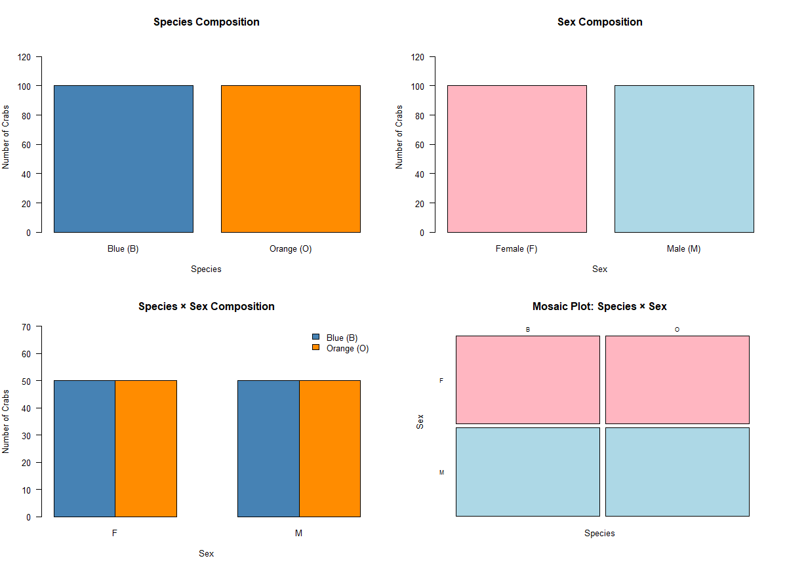

- Comment on each plot
Plot 1 - Species Composition (Simple Bar Chart): Both Blue (B) and Orange (O) species bars reach an identical height of 100, confirming equal representation of each species in the dataset, each accounting for exactly 50% of all observations.
Plot 2 - Sex Composition (Simple Bar Chart): Both Female (F) and Male (M) bars are equally tall at 100, confirming that sex is also evenly distributed, each group making up exactly 50% of the dataset.
Plot 3 - Species × Sex Grouped Bar Chart: All four bars - Blue Female, Blue Male, Orange Female, and Orange Male - stand at an identical height of 50. This confirms that the balance is not merely marginal (i.e., not just equal by species or sex alone) but holds jointly across both categorical variables simultaneously.
Plot 4 - Mosaic Plot (Species × Sex): The mosaic plot is perhaps the most compelling visual evidence. All four rectangles - Blue Female, Blue Male, Orange Female, and Orange Male - are exactly equal in area, each occupying precisely 25% of the total plot space. In a mosaic plot, tile area is proportional to frequency, so equal tile sizes directly indicate equal group sizes.

Conclusion
The crabs dataset is perfectly balanced across all four groups:
Group | Count | Proportion
Blue Female (B, F) | 50 | 25%
Blue Male (B, M) | 50 | 25%
Orange Female (O, F) | 50 | 25%
Orange Male (O, M) | 50 | 25%
Total | 200 | 100%

This perfect balance is a key strength of the dataset. It means that any observed differences in the five morphological measurements (FL, RW, CL, CW, BD) across species or sex groups can be attributed to genuine biological variation rather than being an artefact of unequal sample sizes. It also ensures equal statistical power when performing group comparisons, making the dataset ideal for formal hypothesis testing and comparative analyses.

QUESTION 2 – DISTRIBUTION OF BODY DEPTH

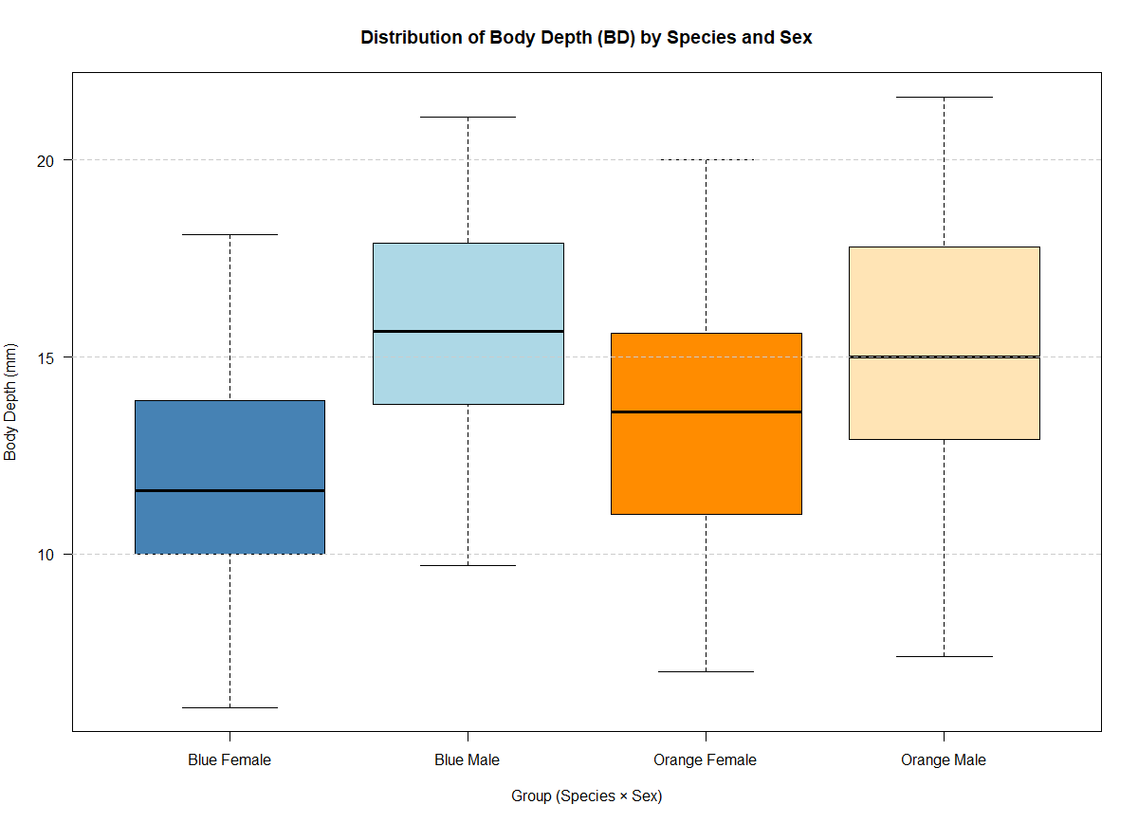

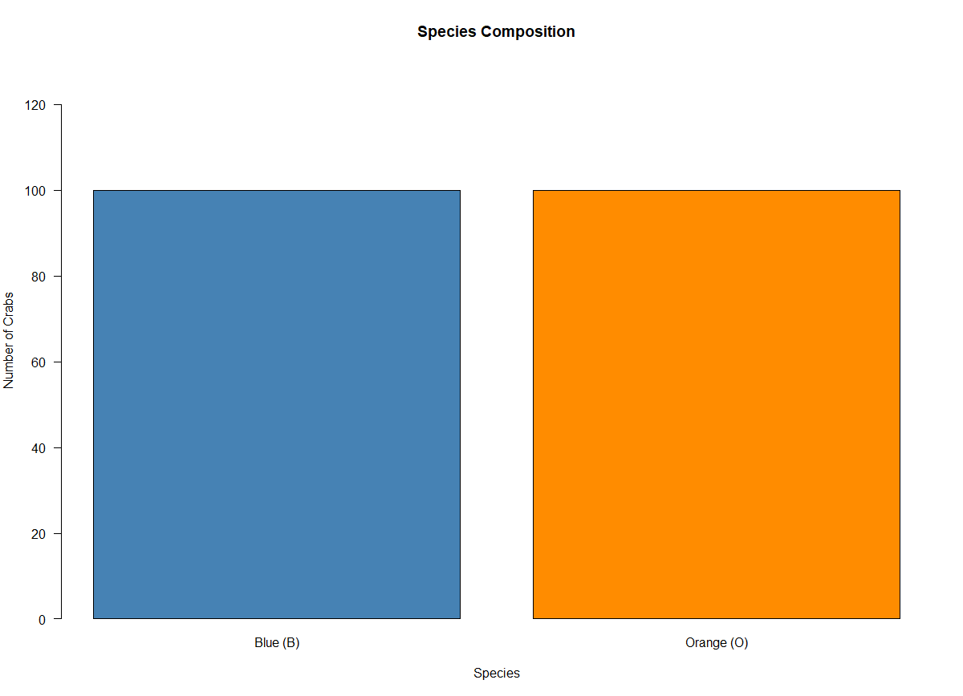

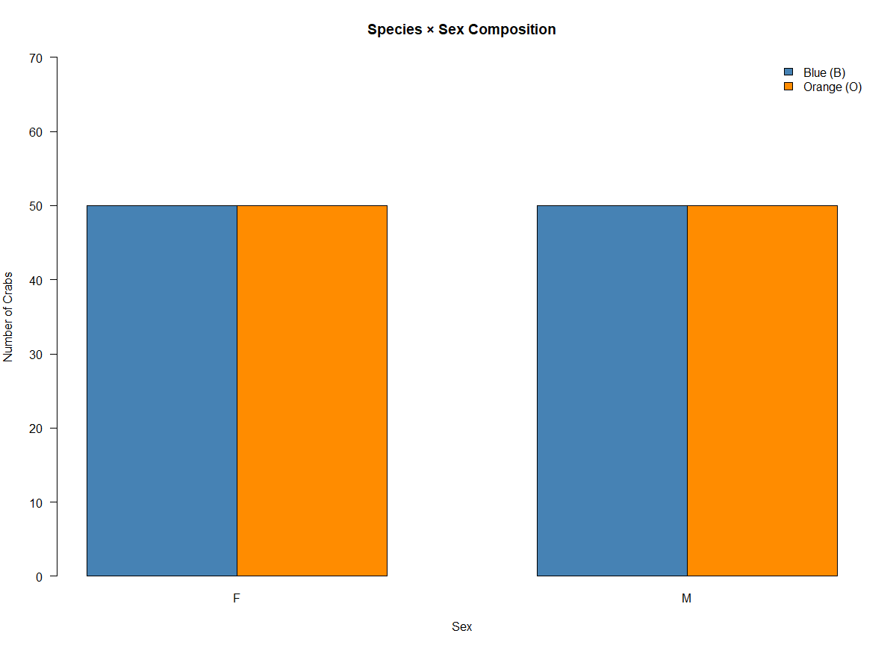
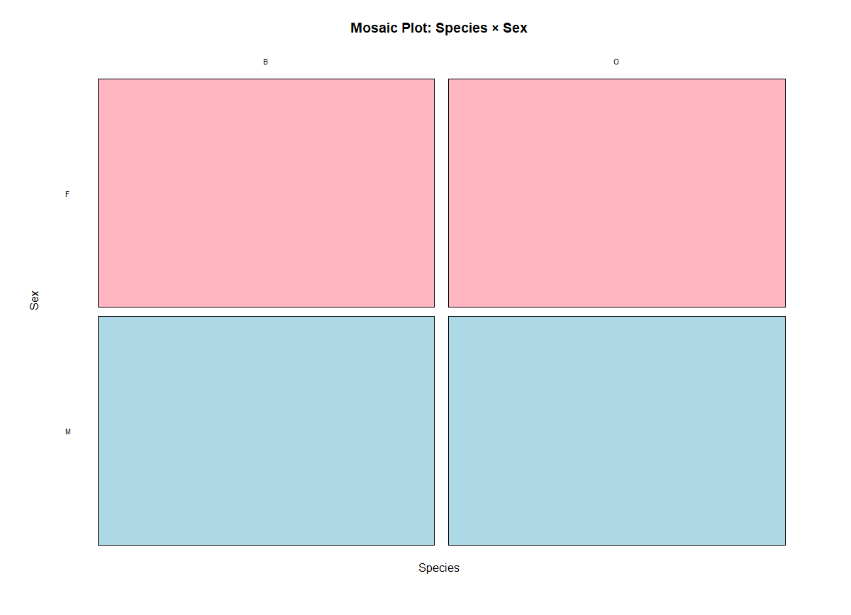
Five-Number Summary (from the plot)

Group | Min (0%) | Q1 (25%) | Median (50%) | Q3 (75%) | Max (100%)
Blue Female | 6.1 | 10.03 | 11.6 | 13.88 | 18.1
Blue Male | 9.7 | 13.8 | 15.65 | 17.85 | 21.1
Orange Female | 7 | 11 | 13.6 | 15.6 | 20
Orange Male | 7.4 | 12.95 | 15 | 17.78 | 21.6

- Outlier Detection
Outlier Detection (IQR Method)
Using the standard rule that a value is an outlier if it falls below Q1 − 1.5×IQR or above Q3 + 1.5×IQR:
Group | Q1 | Q3 | IQR | Lower Fence | Upper Fence | Min | Max | Outliers
Blue Female | 10.03 | 13.88 | 3.85 | 4.26 | 19.66 | 6.1 | 18.1 | None
Blue Male | 13.8 | 17.85 | 4.05 | 7.73 | 23.93 | 9.7 | 21.1 | None
Orange Female | 11 | 15.6 | 4.6 | 4.1 | 22.5 | 7 | 20 | None
Orange Male | 12.95 | 17.78 | 4.83 | 5.71 | 25.03 | 7.4 | 21.6 | None

Central Tendency Comparison
The median is used as the primary measure of central tendency:
- Blue Female records the lowest median body depth of 11.60 mm, making it the smallest group in terms of BD.
- Blue Male records the highest median of 15.65 mm, making it the deepest-bodied group overall.
- Orange Female has a median of 13.60 mm, which is 2.00 mm higher than Blue Female, suggesting Orange females are moderately deeper-bodied than Blue females.
- Orange Male has a median of 15.00 mm, very close to Blue Male (15.65 mm), confirming that males of both species have broadly similar body depths.
Two key patterns emerge from the central tendency comparison. The sex effect is dominant and consistent - within both species, males have substantially higher median BD than females (Blue: 15.65 vs 11.60 mm, a difference of 4.05 mm; Orange: 15.00 vs 13.60 mm, a difference of 1.40 mm). The species effect is comparatively minor - within the same sex, the differences between Blue and Orange crabs are small, particularly for males.

Variability Comparison
The IQR is used as the primary measure of spread:
- Blue Female has the smallest IQR of 3.85 mm, indicating the most uniform and consistent body depths among the four groups.
- Orange Male has the largest IQR of 4.83 mm, indicating the greatest morphological variability in body depth.
- Blue Male (IQR = 4.05 mm) and Orange Female (IQR = 4.60 mm) fall between these two extremes.
The overall range of body depths tells a similar story - Orange Male has the widest range (7.40 to 21.60 mm = 14.20 mm) while Blue Male has the narrowest range (9.70 to 21.10 mm = 11.40 mm). Despite these differences, the spreads across all four groups are broadly comparable, suggesting that while the centres differ markedly between sexes, the degree of variability within each group is relatively similar.

Overall Conclusion
Feature | Finding
Outliers | None detected in any group
Highest Median BD | Blue Male (15.65 mm)
Lowest Median BD | Blue Female (11.60 mm)
Most Variable Group | Orange Male (IQR = 4.83 mm)
Least Variable Group | Blue Female (IQR = 3.85 mm)
Dominant Effect | Sex - males are consistently deeper-bodied than females across both species

QUESTION 3 – CARAPACE LENGTH DISTRIBUTION BY SPECIES
- Histogram of carapace length for each species
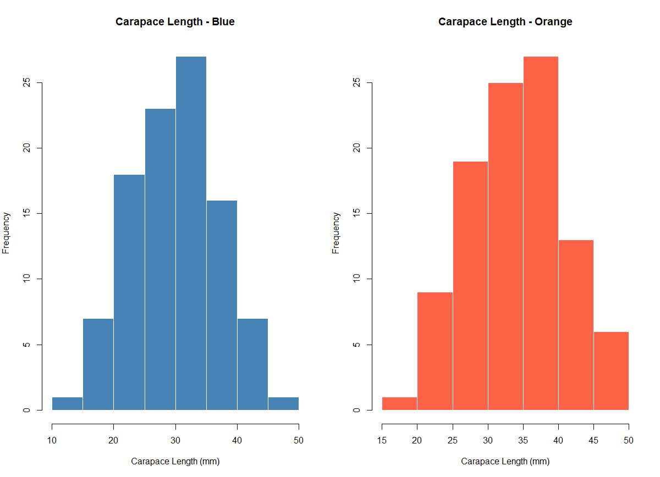

- Species Shape Description
Blue: | Approximately unimodal and roughly symmetric, with the peak around 30–35 mm. There is a slight right skew, as the distribution extends further toward 50 mm with a thin tail, while the left tail drops off more sharply below 15 mm. The range spans approximately 10–50 mm.
Orange: | Approximately unimodal and roughly symmetric, with the peak around 35-40 mm. There is a slight left skew, as a few crabs have noticeably shorter carapace lengths pulling the left tail toward 15 mm, while the right tail tapers off around 50 mm. The range spans approximately 15–50 mm.
Comparison:
Both distributions are unimodal and approximately symmetric, but they differ in two key respects. First, the Orange distribution is shifted slightly to the right compared to Blue, suggesting that Orange crabs tend to have somewhat longer carapaces on average. Second, the skewness patterns differ subtly - Blue shows a slight right skew (longer right tail) while Orange exhibits a slight left skew (longer left tail). Both species show similar overall spread,

QUESTION 4: COMPARISON OF THE MEAN MEASUREMENT

- Compute the mean of each morphological measurement (FL, RW, CL, CW, BD) by species and sex
MEAN:
Species | Sex | FL (mm) | RW (mm) | CL (mm) | CW (mm) | BD (mm)
Blue | Female | 13.27 | 12.138 | 28.102 | 32.624 | 11.816
Orange | Female | 17.594 | 14.836 | 34.618 | 39.036 | 15.632
Blue | Male | 14.842 | 11.718 | 32.014 | 36.81 | 13.35

- Construct a grouped bar chart to display these means

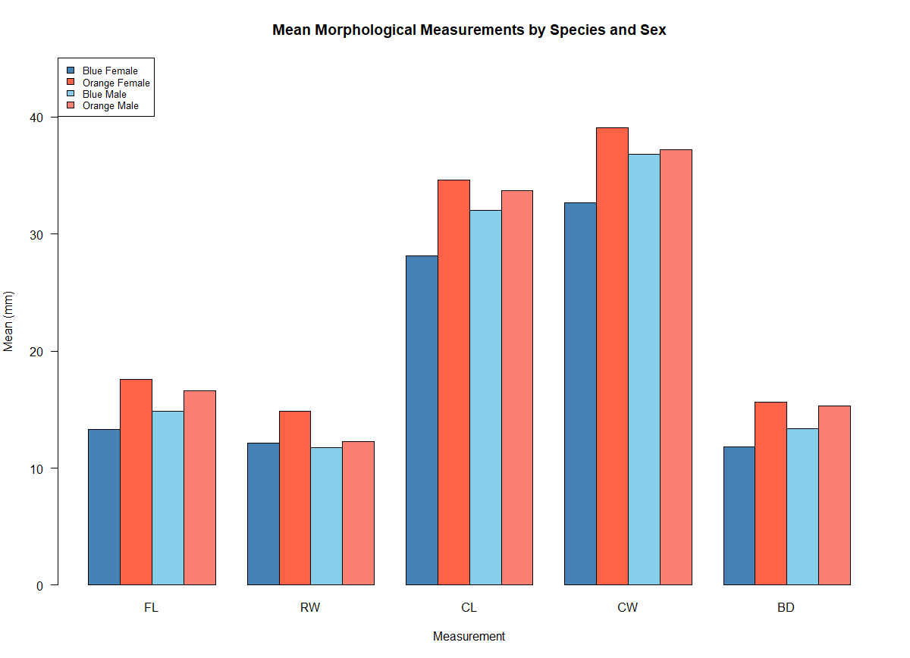

Chart Commentary:
The grouped bar chart reveals several clear patterns. Orange females (dark red) consistently have the tallest bars across most measurements, particularly for CL, CW, and BD, indicating they tend to be the largest group overall. Blue females (dark blue) have the shortest bars across nearly all measurements, making them the smallest group.
A notable exception is rear width (RW), where Orange females have the highest mean (~14.8 mm) while males of both species have lower values (~11.7–12.3 mm). This reversal - females exceeding males - is unique to RW and likely reflects the biological need for a wider abdomen in females for egg carrying.
For carapace-related measurements (CL and CW), the species effect is most prominent: Orange crabs are generally larger than Blue crabs regardless of sex. The sex differences within species are more modest by comparison.

- Sex difference output

The absolute sex differences across the five measurements are:
FL | RW | CL | CW | BD
0.302 | 1.497 | 1.491 | 1.169 | 0.613
Greatest species difference: Carapace Length (CL) - with a mean difference of 4.095 mm between Orange and Blue crabs. CL shows the widest gap between species, indicating it is the most species-dependent morphological trait. This is visually confirmed in the bar chart where the Orange bars tower over the Blue bars most prominently for CL.
Least sex variation: Frontal Lobe (FL) - with an absolute difference of only 0.302 mm between males and females. This is remarkably small compared to the other measurements, suggesting that frontal lobe size is almost entirely determined by species rather than sex. By contrast, RW (1.497 mm) and CL (1.491 mm) show the largest sex differences, indicating these measurements are more sexually dimorphic.

QUESTION 5: RELATIONSHIP BETWEEN MEASUREMENTS

- The scatter plot matrix (pair plot) of the five measurements.
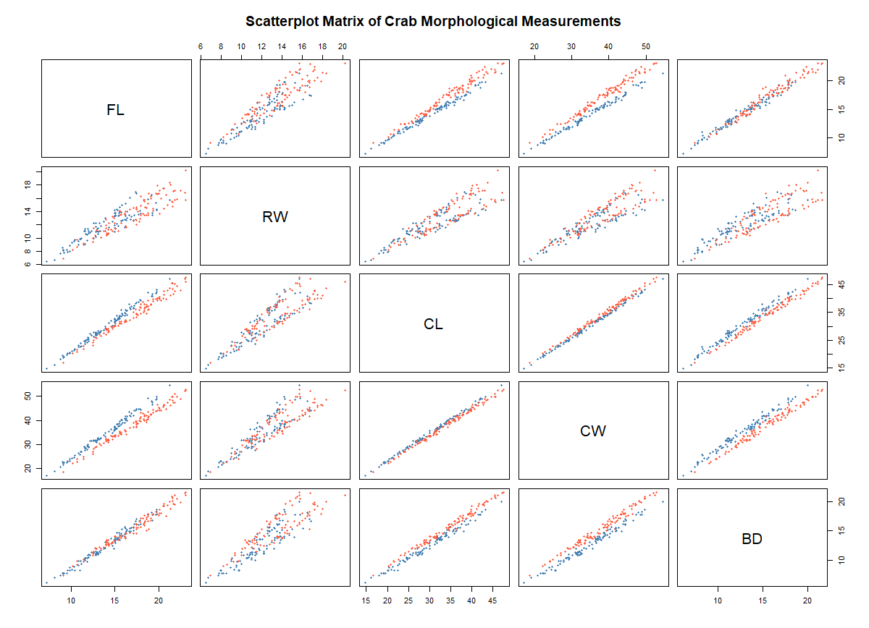

- Strength and the nature of the relationship among variables
Overall Pattern:
All pairwise scatterplots display strong positive linear relationships - as one measurement increases, the other tends to increase proportionally. This is expected since all five variables measure different aspects of body size, and larger crabs will tend to be larger on all dimensions.
Strongest Relationships:
The tightest linear associations (with minimal scatter around an imaginary trend line) appear between CL and CW, CL and BD, and CW and BD. These carapace-related measurements are highly correlated, with points forming narrow elongated clouds. This makes biological sense as carapace length, width, and body depth are structurally connected dimensions of the shell.
Moderate to Strong Relationships:
FL shows strong positive associations with CL, CW, and BD, though with slightly more scatter than among the carapace variables themselves. This suggests that frontal lobe size scales reliably with overall body size but with somewhat more individual variation.
Weakest (but still positive) Relationship:
RW stands out as having the weakest correlations with the other variables. Its scatterplots show the widest scatter and the most visible separation between species. In particular, the FL vs RW plot reveals two distinct species-specific clusters - for a given frontal lobe size, Orange crabs (red) tend to have higher RW while Blue crabs (blue) tend to have lower RW, or vice versa. This indicates that rear width is the most species-dependent measurement and carries the most discriminatory information in this matrix.
Species Patterns:
In most plots, the Blue and Orange points overlap substantially and follow a common trend, indicating that the allometric relationships are similar across species. However, in plots involving RW, the two species form noticeably separate trajectories, confirming that RW has a distinct species-specific scaling pattern. This makes RW particularly useful for distinguishing between Blue and Orange crabs beyond what overall body size alone can explain.

QUESTION 6: INTEGRATED STATISTICAL REPORT;
Introduction
The crabs dataset from the MASS package in R contains 200 morphological observations of Leptograpsus variegatus crabs collected at Fremantle, Western Australia. Five body measurements — frontal lobe size (FL), rear width (RW), carapace length (CL), carapace width (CW), and body depth (BD) — are recorded in millimetres across two species (Blue and Orange) and both sexes, with 50 observations per group. This report synthesises findings on distributional shape, species and sex differences, and inter-variable relationships.
Distributional Shape
Histograms of carapace length reveal that both species exhibit approximately unimodal and symmetric distributions, differing primarily in location rather than shape. The Orange distribution is shifted to the right relative to Blue, indicating longer carapaces on average. Blue crabs show a slight right skew, while Orange crabs display a subtle left skew. Both span a comparable overall range, suggesting that within-species variability in carapace length is similar across the two groups.
Species and Sex Differences
Orange crabs are generally larger than Blue crabs across most measurements, with the species effect most pronounced in carapace length - the measurement exhibiting the greatest mean difference between species. Females of both species tend to have wider rear widths than males, likely reflecting an adaptation for egg carrying, making rear width the most sexually dimorphic trait. In contrast, frontal lobe size shows the least sex variation, indicating it is driven almost entirely by species rather than sex. The interaction between species and sex is also noteworthy: Orange females are particularly large relative to Blue females, while the difference between males of the two species is more modest.
Relationships Between Measurements
The scatterplot matrix reveals strong positive linear relationships among all five variables, consistent with allometric growth - larger crabs are proportionally larger on every dimension. The tightest associations occur among the carapace-related variables (CL, CW, BD), which form narrow elongated point clouds. Frontal lobe size also scales strongly with body size, though with somewhat more scatter. Rear width stands apart as having the weakest overall correlations and the most pronounced species separation; for a given body size, Blue and Orange crabs follow distinct RW trajectories, making it the most taxonomically informative variable in bivariate space.
Conclusion
The two species of Leptograpsus variegatus are morphologically distinct, with carapace length providing the clearest species separation and frontal lobe size showing the least sexual dimorphism. All measurements are tightly intercorrelated through allometric scaling, but rear width uniquely captures species-specific variation beyond overall body size. Within each species, distributions are well-behaved - approximately symmetric and unimodal - supporting the use of standard parametric methods in subsequent inferential analyses.

